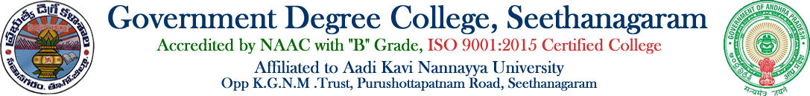

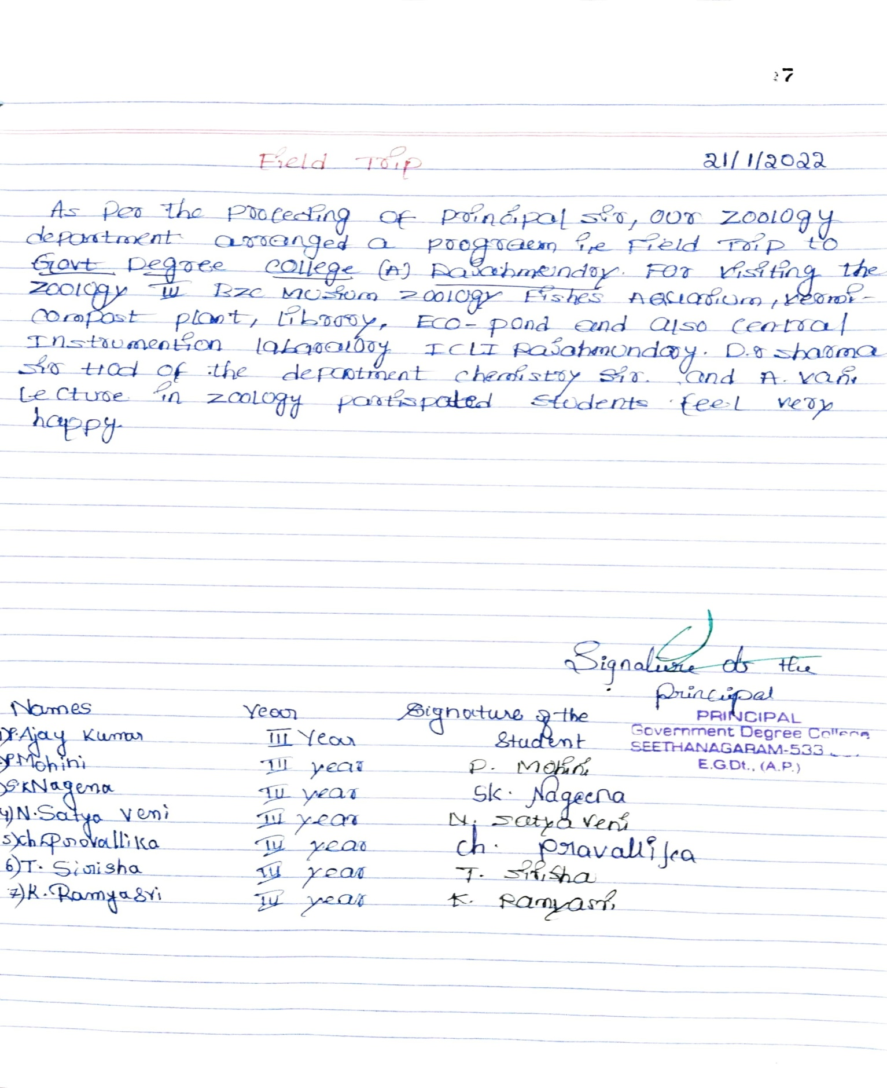
DEPARTMENT OF ZOOLOGY
FIELD TRIP

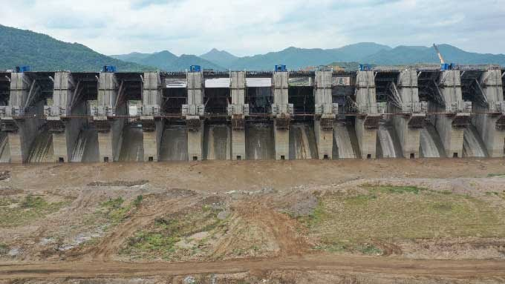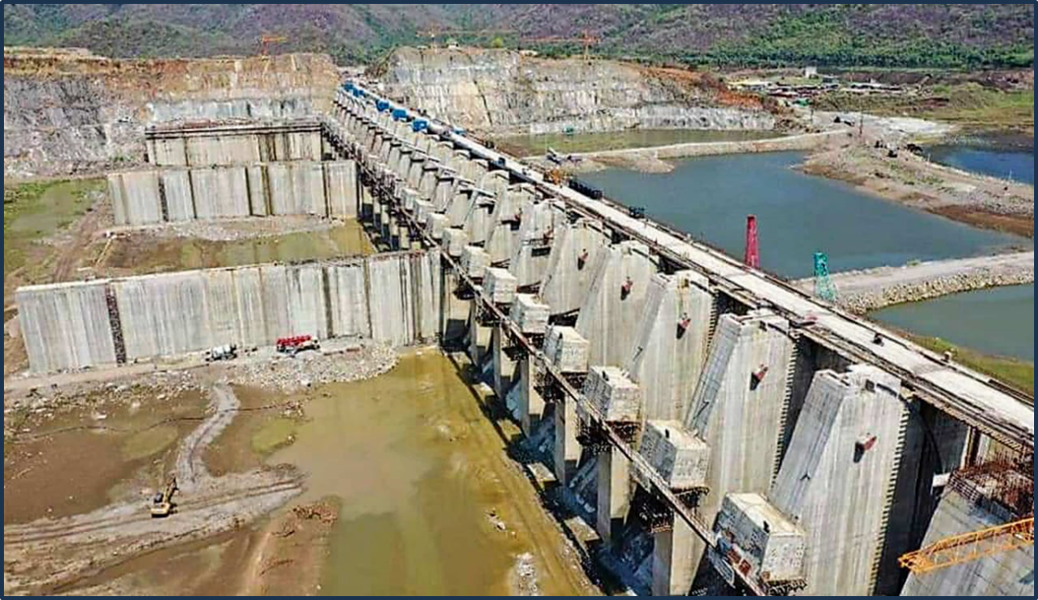
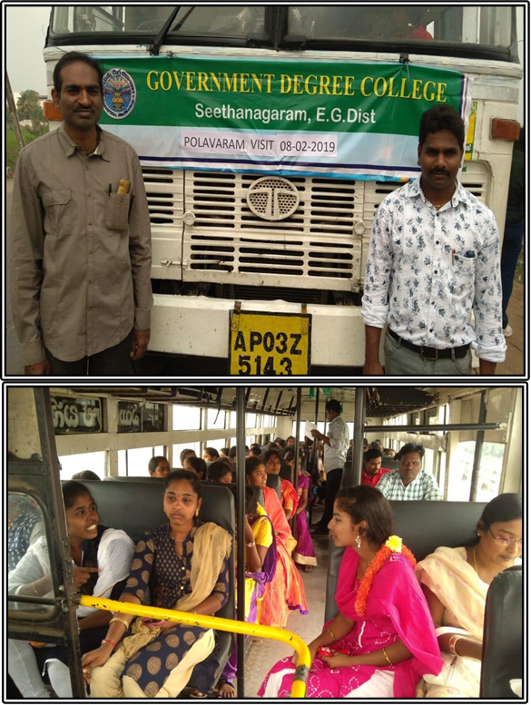
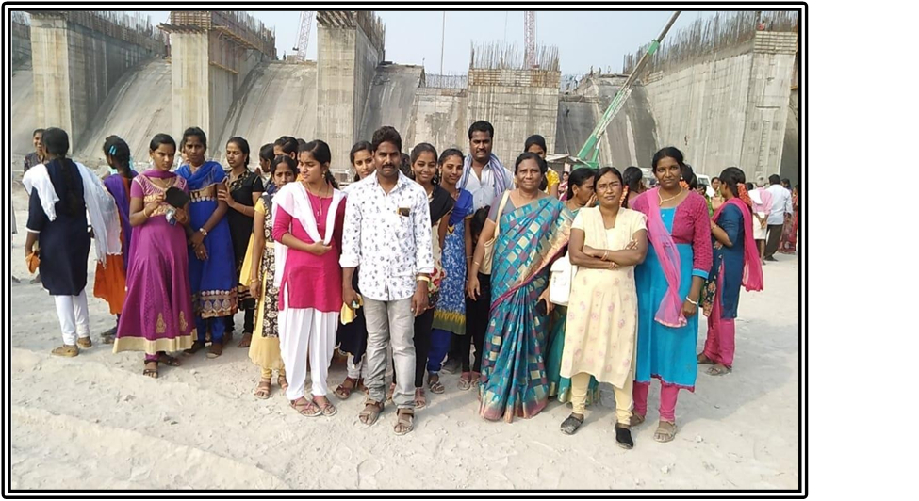

DEPARTMENT OF ZOOLOGY

FIELD TRIP- 21-01-2022
As per the proceedings of the principal sir, our zoology department arranged a field trip. i.e. Government degree College Rajahmundry. For visiting the zoology museum, fishes Aquarium, vermicompost plant, Library. To this A.vani and Dr.Sharma sir lecture in charge of chemistry participated in the field trip. Students feel happy
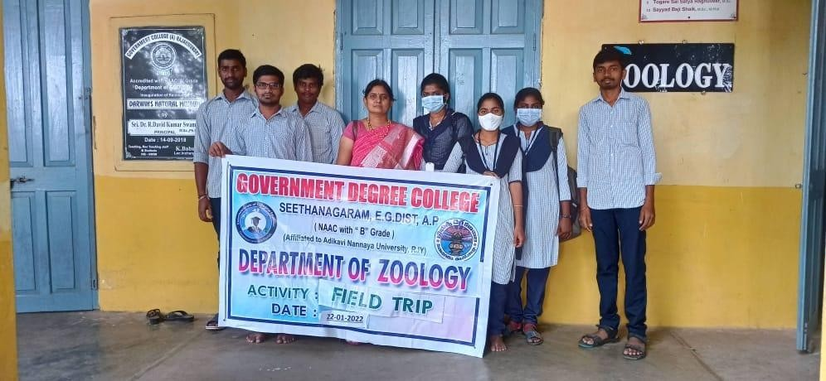
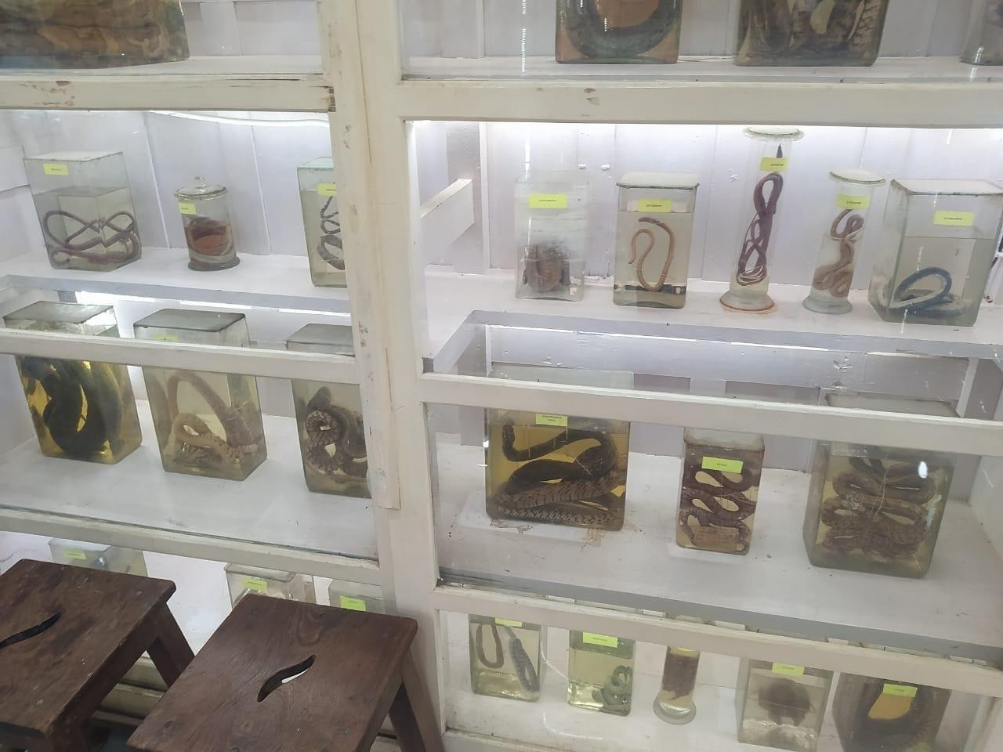
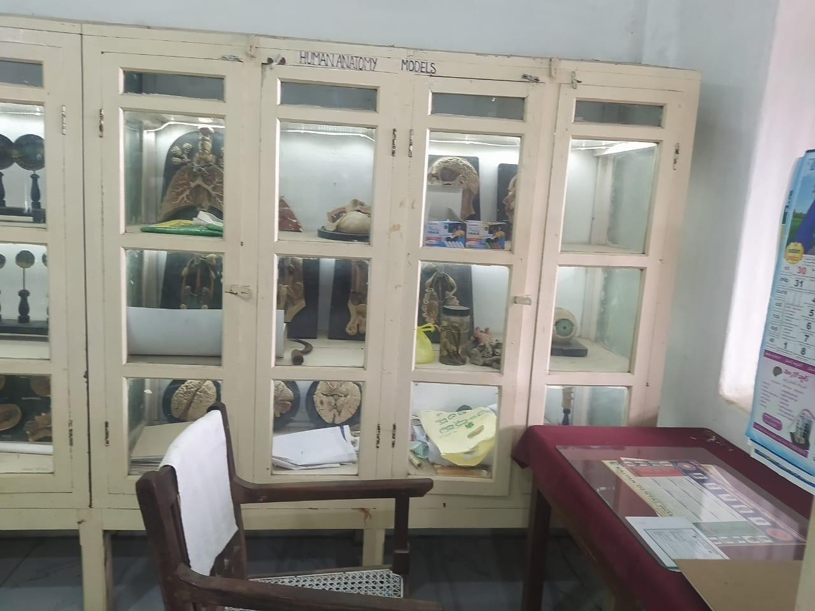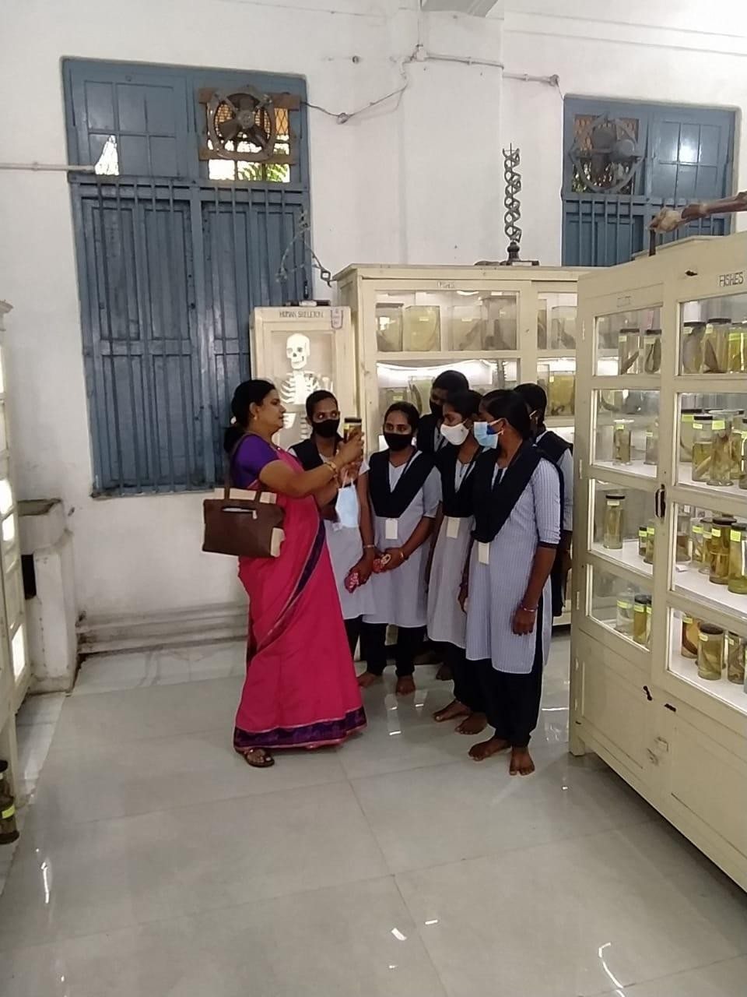

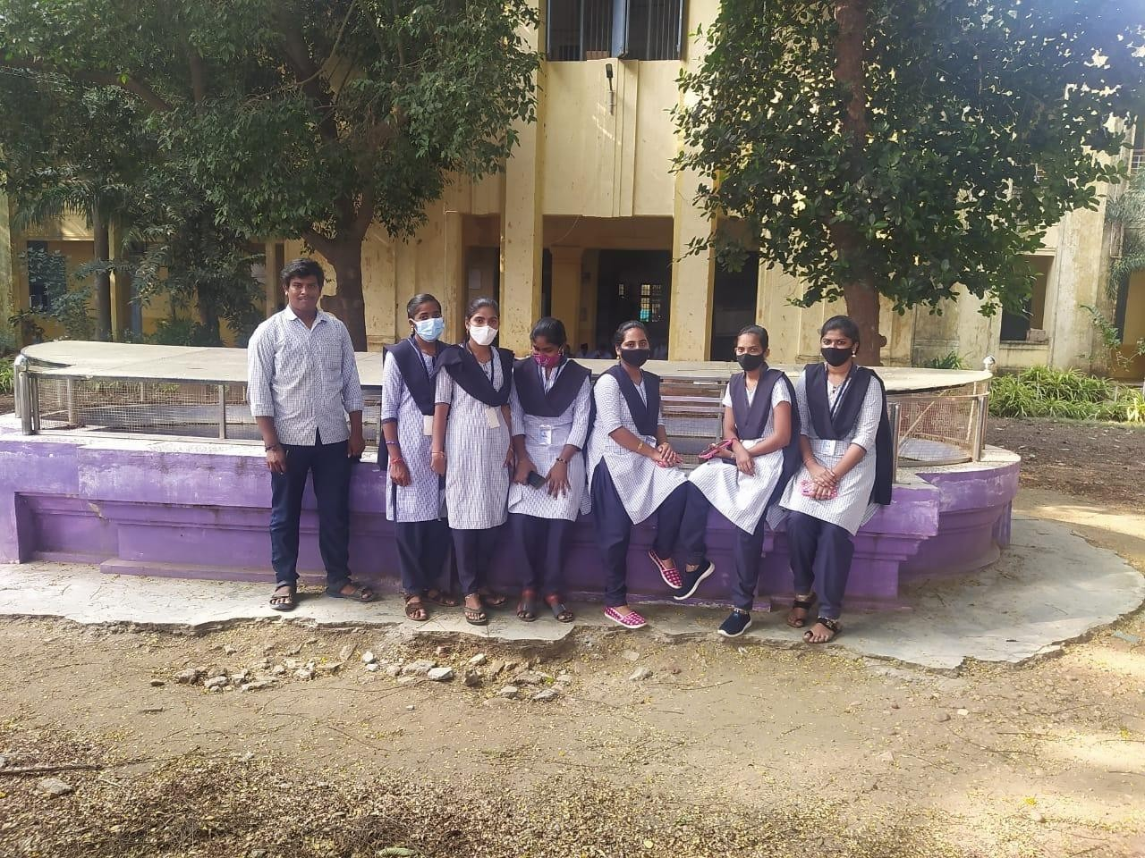

DEPARTMENT OF ZOOLOGY

FIELD TRIP- 22-01-2022
As per proceedings of principle sir, our zoology department arranged a field trip i.e. Government degree College Rajahmundry for visiting the canter instrumentation laboratory, to the botanical garden, botany museum, and to observe the medical plants.Dr.A.srinivas sir delivery about medical plants.

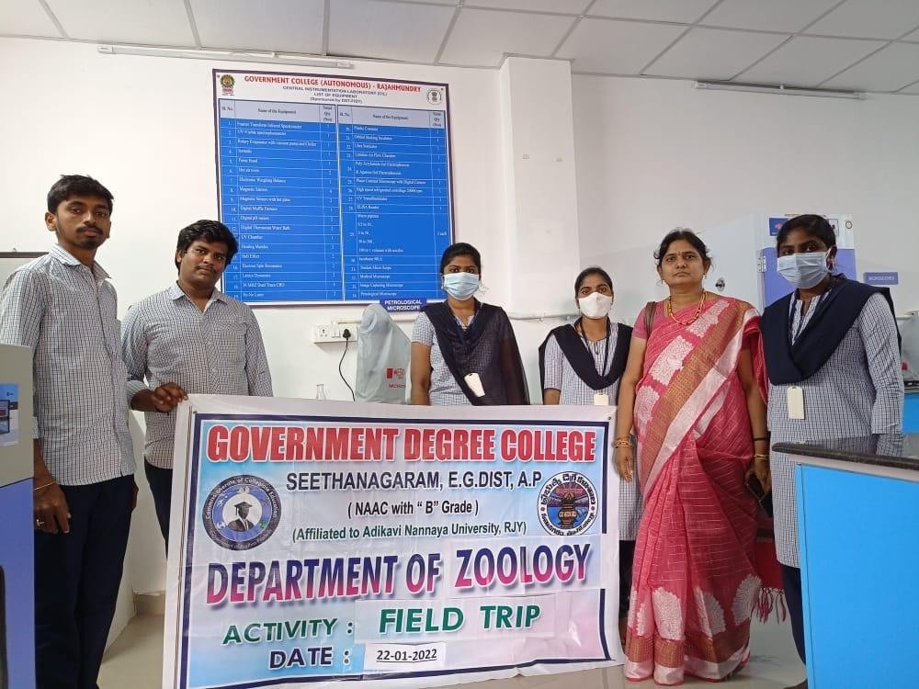
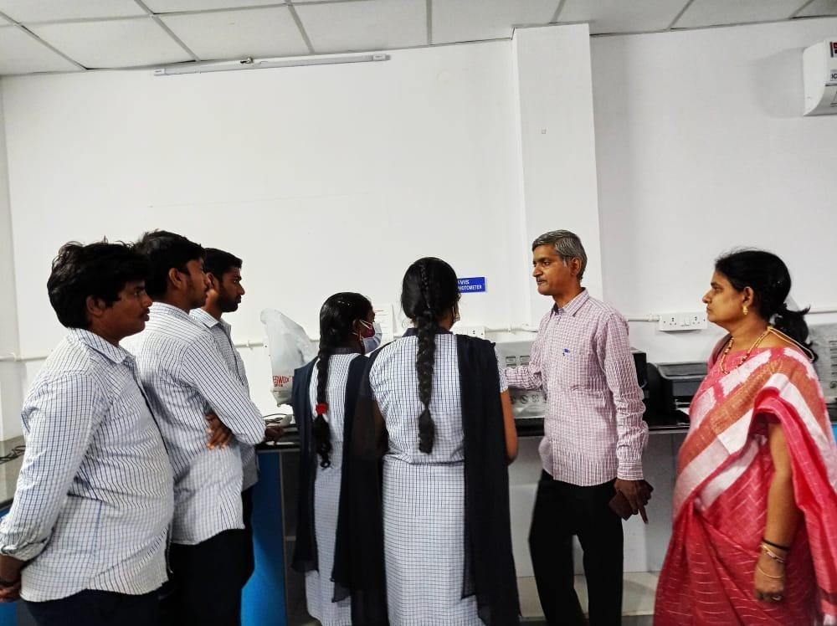
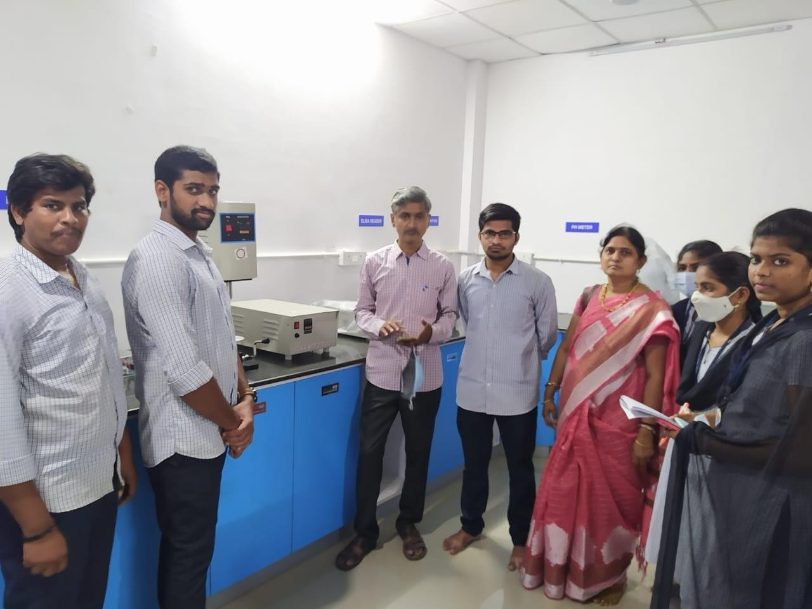

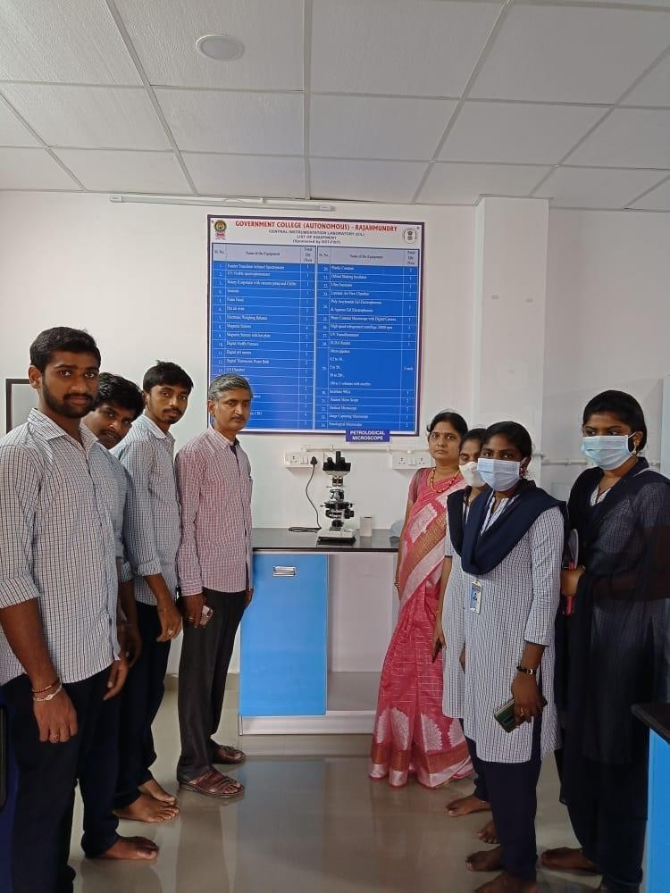
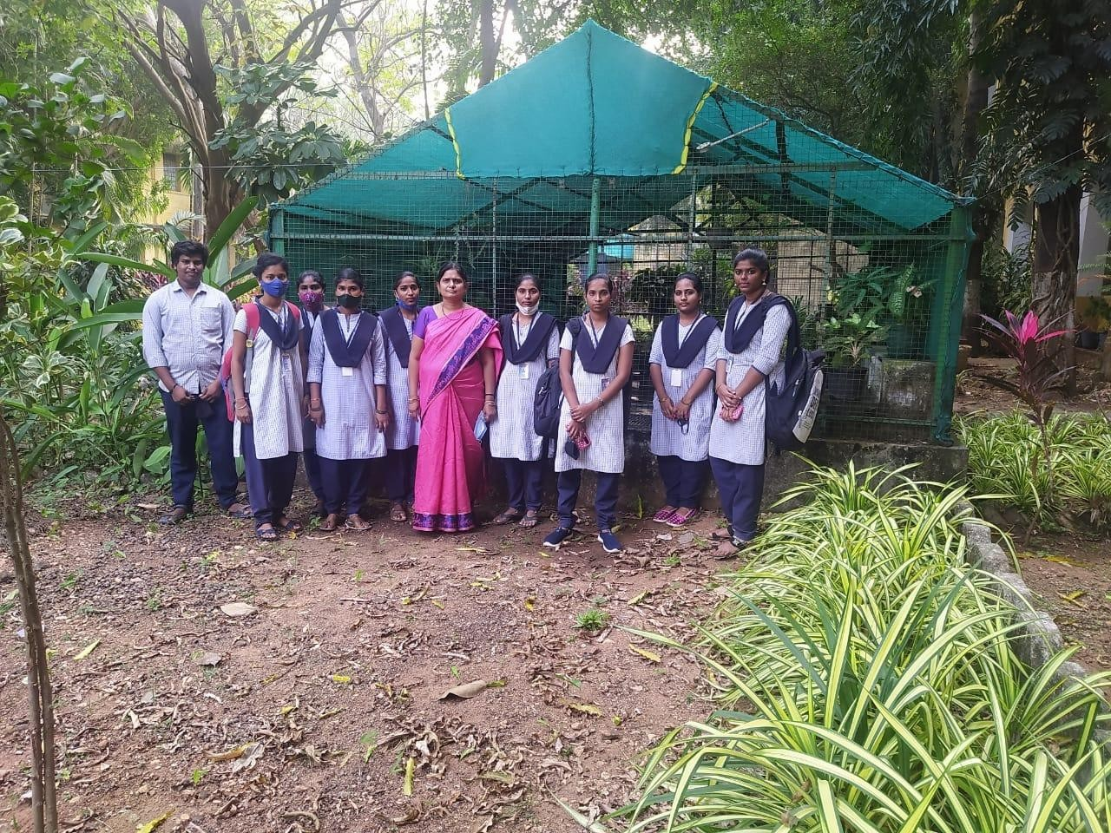

DEPARTMENT OF ZOOLOGY

ZOOLOGY FIELD TRIP 29thAUGUST, 2022
About Field Trip:
“A visit (Industry) made (as by students and a teacher) for purposes of first-hand observation”. It gives young people the chance to experience cultures, respect differences, and develop new friendships with their peers and thus broaden their
horizons and knowledge. Tours are a strong way to consolidate learning, the experience from a trip can be directly related to the real world.
Introduction:
On 29th August, 2022, eleven I B.Sc., (B.Z.C) students with one lecturers went for a trip to Fish Breeding Centre Kadiyam with an aim to visit to improve skills in Breeding
Centre; we planned to visit the breeding center for learning the skills in the organization

Objectives:
The objectives of the trip were to get to know the technical skill in more details about fish indused breeding , to get exposure on products and also to learn about
feedmanagement,nursery management

Observations:
We were guided by tour by Sri. D.Gopal rao HR Manager who explained in details about the fishes. During the tour, our students noted down some notes and
interviewed the host about the induced breeding. There was an interactive session between HR Manager and students, as they clarified their doubts. Our students learned various things about the breeding center and visited the plant and observed the ponds.And learned about induced breeding.

Conclusion:
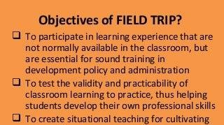It can be concluded that trip was successful and we believed that our objective was achieved. Our students learned something new and beneficial
About Field Trip: “A visit (Industry) made (as by students and a teacher) for purposes of firsthand observation”. It gives young people the chance to experience cultures, respect differences, and develop new friendships with their peers and thus broaden their horizons and knowledge. Tours are a strong way to consolidate learning, the experience from a trip can be directly related to the real world.
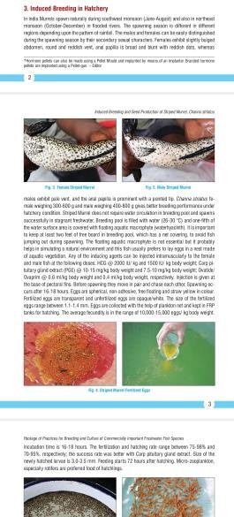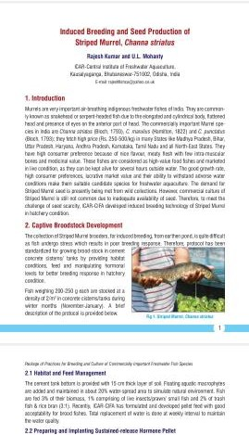
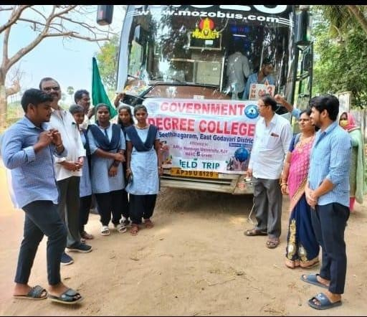 PHOTOS GALLARY
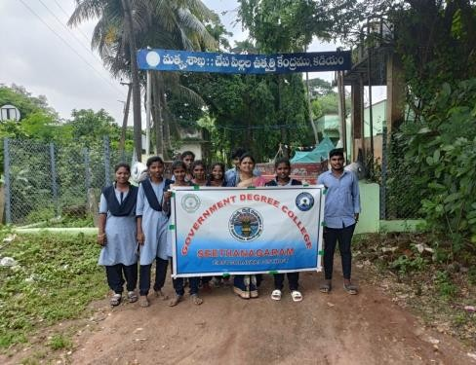
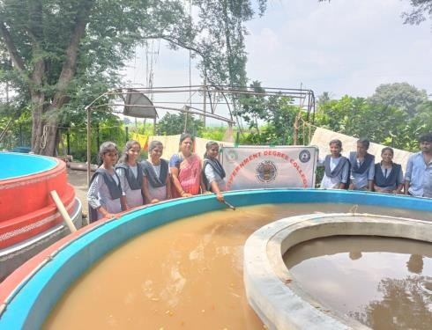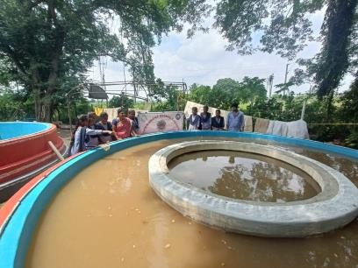

Fish Breeding Centre Kadiyam

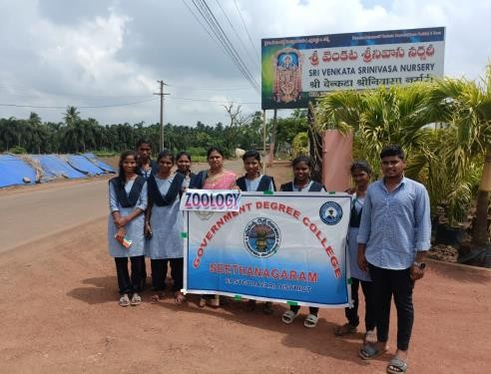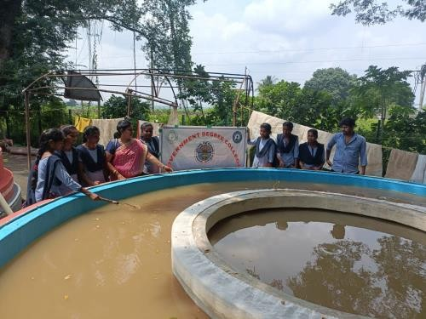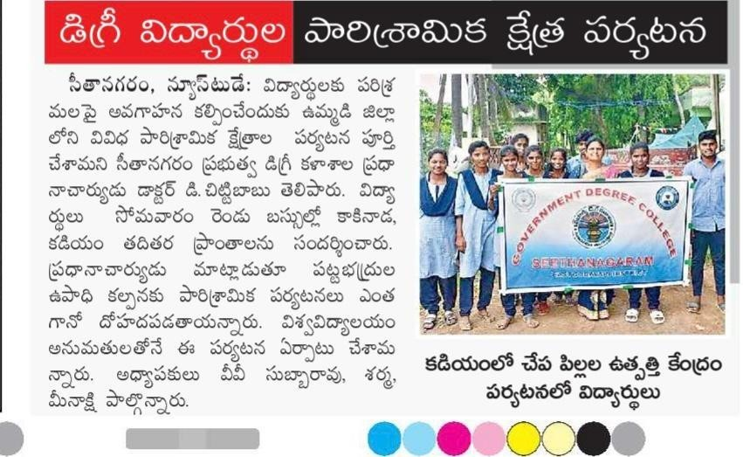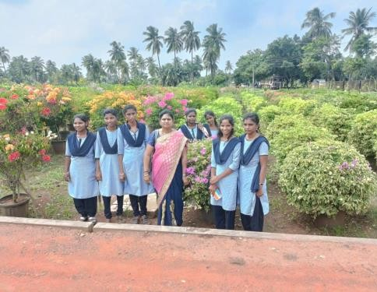

DEPARTMENT OF ZOOLOGY
ZOOLOGY FIELD TRIP 30th AUGUST,2022
About Field Trip:
“A visit (Industry) made (as by students and a teacher) for purposes of first-hand observation”. It gives young people the chance to experience cultures, respect differences, and develop new friendships with their peers and thus broaden their
horizons and knowledge. Tours are a strong way to consolidate learning, the experience from a trip can be directly related to the real world.
Introduction:
On 30th August, 2022, eleven III B.Sc., (B.Z.C) students with one lecturers went for a trip to Siri Venkata Srinivasa Nursey Kadiyam with an aim to visit to improve skills in nursey

photos Gallary

Sri Venkata Srinivasa Nursery kadiyam
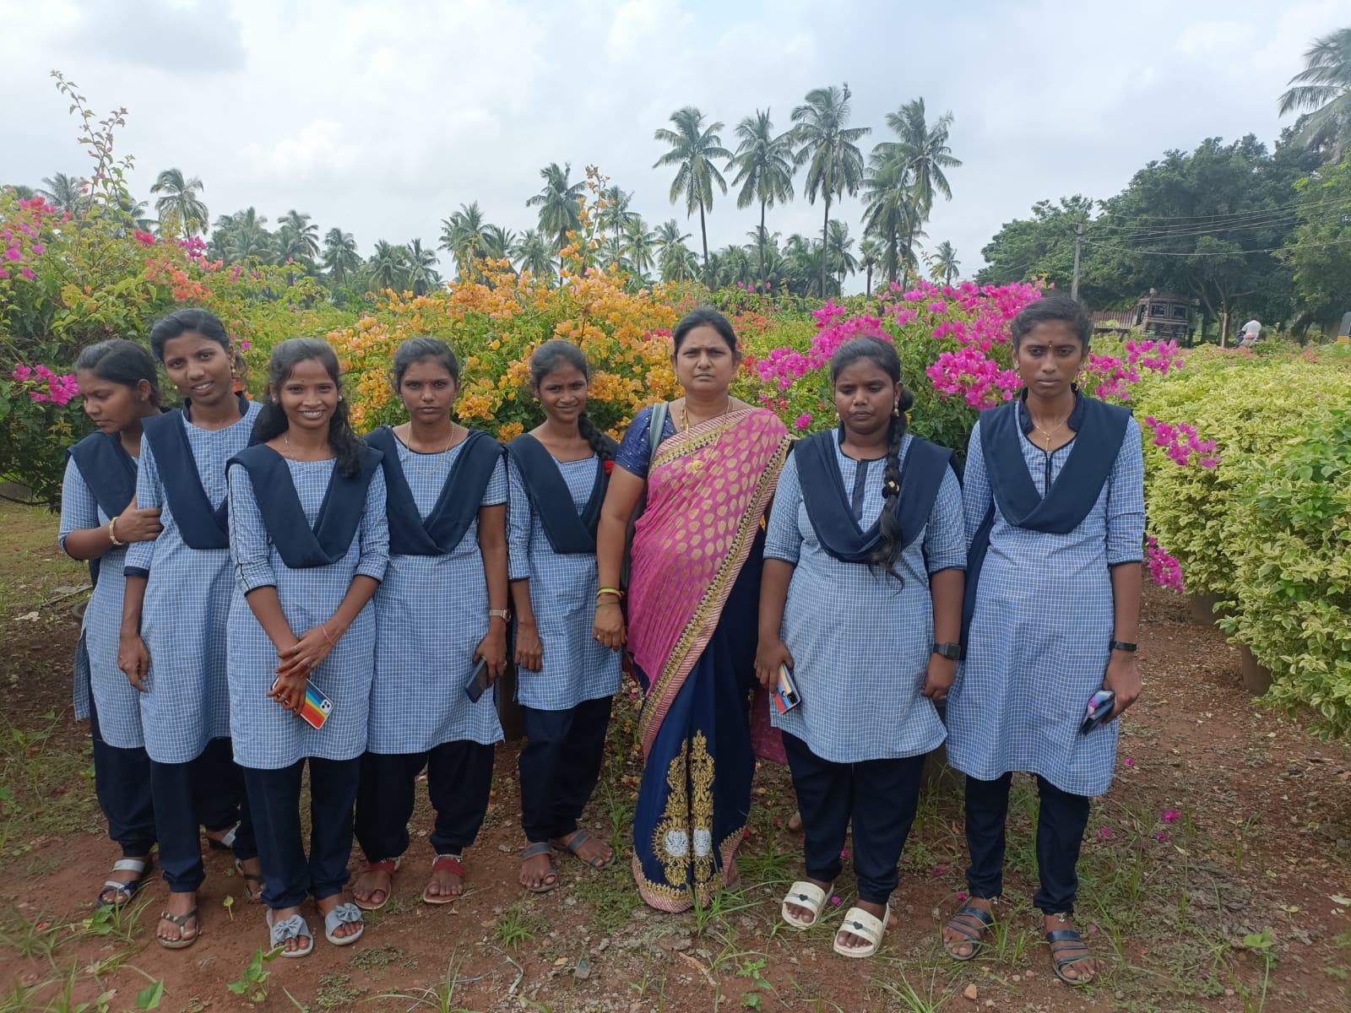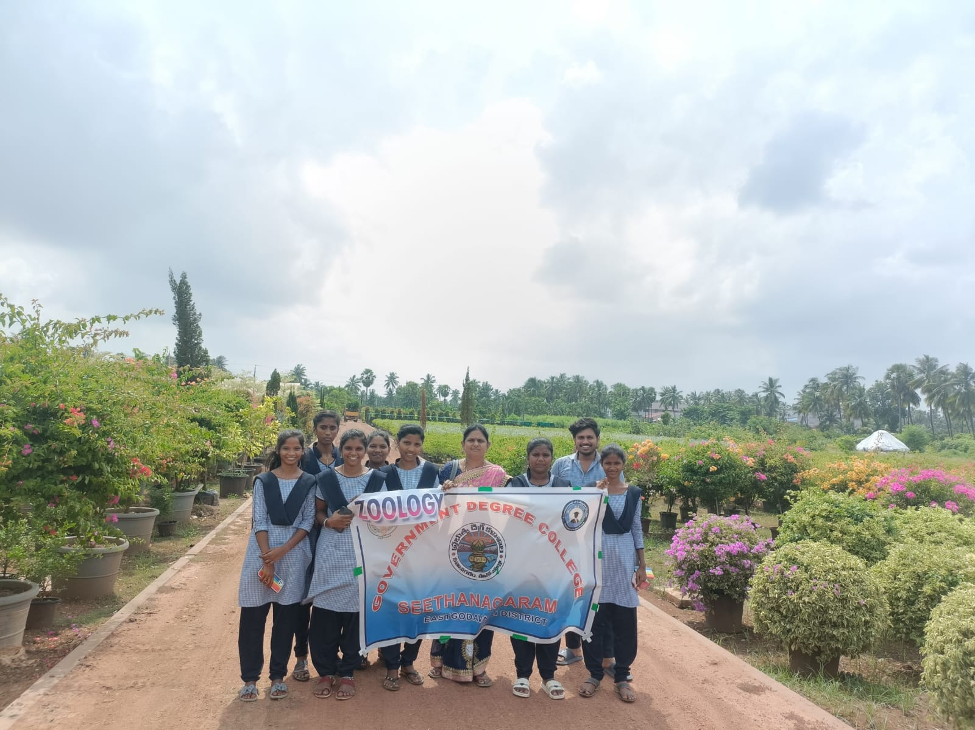

DEPARTMENT OF ZOOLOGY

ZOOLOGY FIELD TRIP 24th January,2023

As per the proceding of principal sir,our zoology department arranged a program vermicompost to singavaram which is near to seethanagarm

